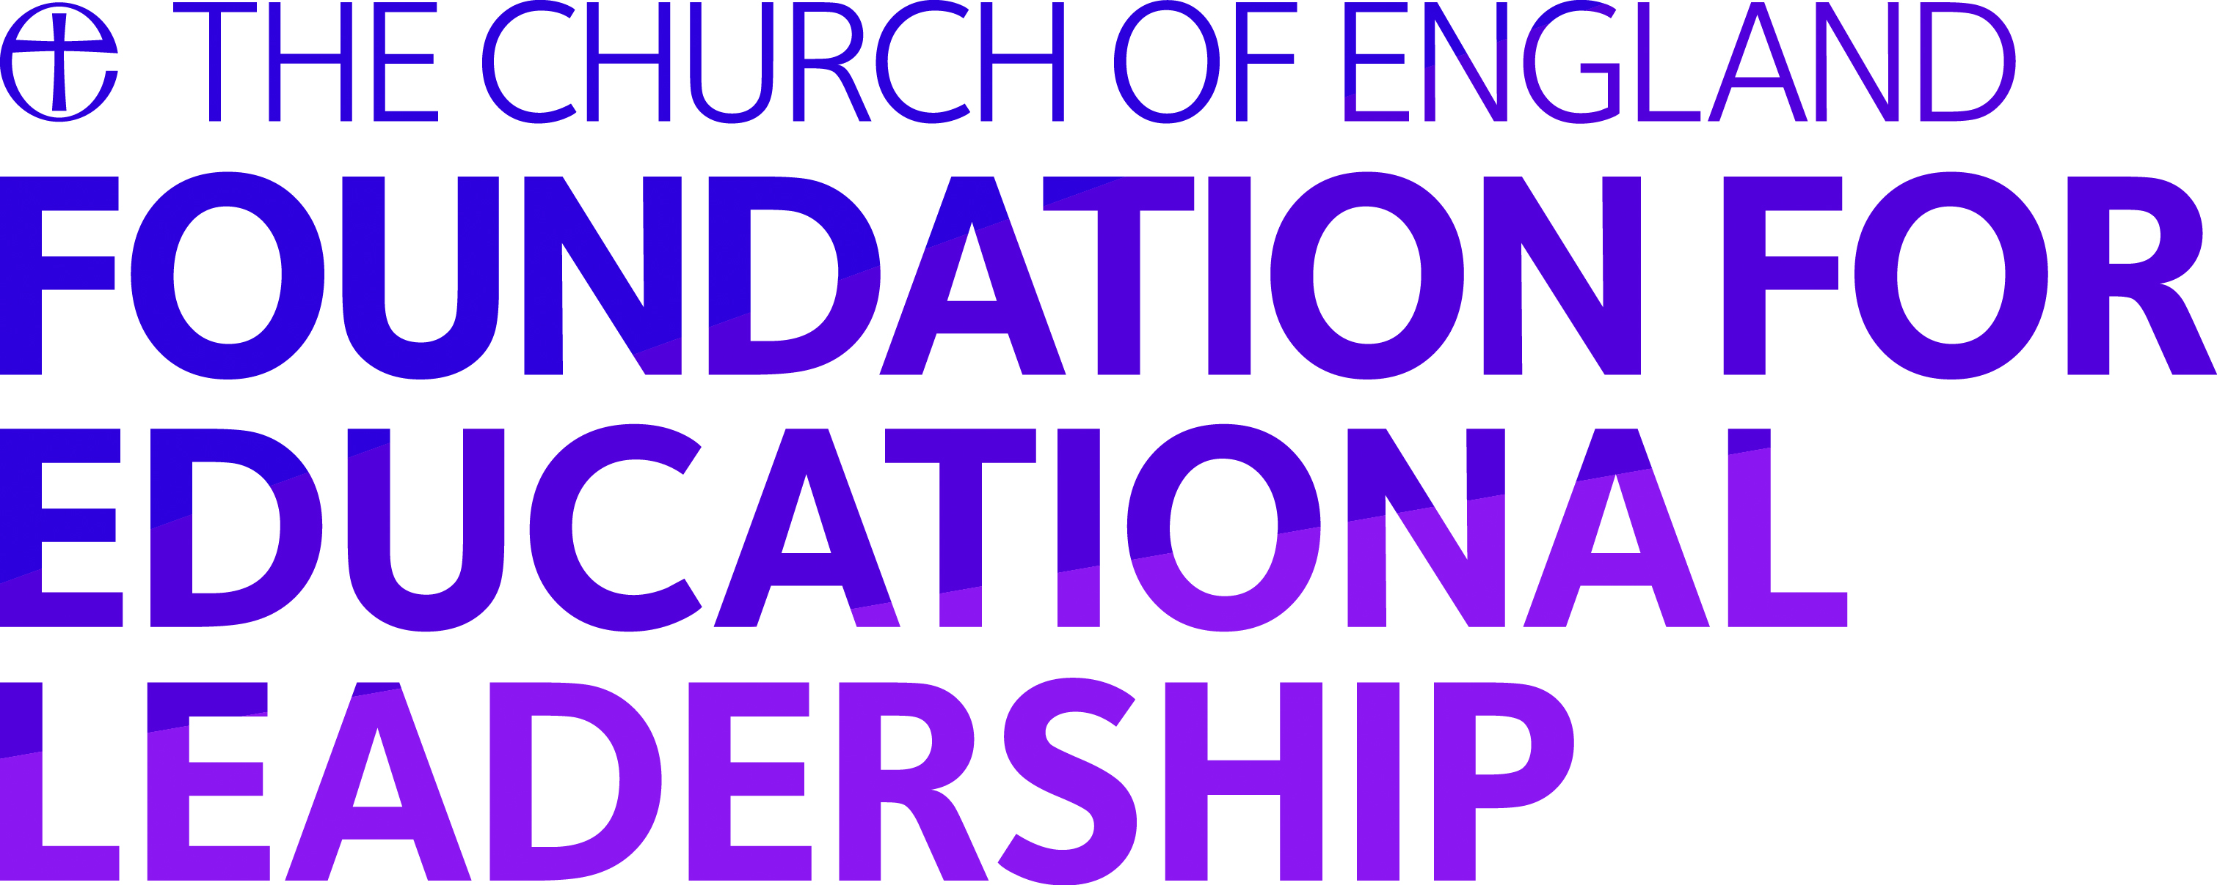

Programmes
Church of England Professional Qualification for Headship (CofEPQH)
Frequently Asked Questions

1. How long does the programme last?
The programme will run from Spring 2018 to Summer 2019. It will therefore take 18 months to complete and run across two academic years.
2. How much does it cost?
The total cost of CofEPQH is £1950 + VAT
3. Do I get a discount if I am a small school?
There are a limited number of bursaries available for participants. In the first instance, we ask that you contact cefel@churchofengland.org to discuss your particular context.
4. Can I spread the cost over 2 financial years?
Yes. Further information will be provided on the application forms which are available to download from our website.
Once you have been accepted on to the programme and paid the deposit no refunds can be made for cancellation.
5. My school budget can't cover the cost of the programme what can I do?
Funding for this programme may be secured from a variety of sources. Participants on similar programmes have covered the cost through school funds; personal contribution; church contributions as well as charitable donations. It is worth making enquiries to ascertain if there is funding available from alternative sources.
6. If I want to withdraw from the programme and I don't want to continue what happens?
Whilst we encourage all participants to try and complete the programme we appreciate that sometimes this is not possible. We do not typically offer refund on course fees, however this may be possible in exceptional circumstances.
7. What is the criteria for joining the programme?
You need to be a Senior Leader/Aspiring Senior Leader within a school or be in the early part of your career as a Head. Your application must be supported by the headteacher of the school you currently work in or your Trust CEO or Chair of Governors if you are a serving headteacher.
Your sponsor must indicate their support for you taking the necessary time out of school to complete the qualification.
8. Who will be my mentor?
Participants will be responsible for finding their own mentor – this might be a colleague who is already working with you in school or from another organisation. The mentor should have experience of working at a senior level within a school context. They may be serving practitioners or having recently left the profession. It will be for you and your mentor to decide how you would like to work together - face to face, skype, phone call etc. Mentors must attend the mentor briefing scheduled via webinar in December and will have the option of completing a 1 day certificate in Coaching and Mentoring (provided by 3D Coaching, in line with International Coaching Federation criteria).
9. Will I get to visit other schools?
Yes, school visits will be organised throughout the duration of the course and will be focused on key elements of the programme. You will also undertake an extended seven day school placement as part of the programme.
10. Do you have to be a Christian take part in this programme?
This programme is open to everyone regardless of their religion. It is designed to be fully aligned with the Church of England's vision for education https://www.churchofengland.org/education/publications.aspx and therefore participants will be engaging with this vision throughout the programme.
Each face to face learning event will begin with a short period of collective worship.
11. Is the programme the same as NPQH?
Yes. The programme incorporates the NPQ content areas and core practical elements necessary to build a successful school, whilst also being rooted in the Church’s vision for education.
12. Can I do this programme if I already have NPQH?
We recommend that you discuss your professional experience and skills with a member of the Programmes team to ensure that you will receive appropriate professional development by taking part in their programme.
13. I don't have NPQH but I've been a serving head for 2 or more years, can I still do the programme?
We recommend that you discuss your professional experience and skills with a member of the Programmes team to ensure that the Foundation will provide you with appropriate professional development.
14. Is the programme open to me if I'm not in a church school?
Yes the CofEPQH is open to leaders in secondary and primary schools in Church of England, community or other faith schools.
15. How will I be assessed?
Participants will complete two projects: 1) Leading a whole-school change programme (4,000 words), and 2) Designing an action plan to meet your placement school’s resourcing and capability needs (2,500 words). These will be submitted at the end of the programme.
16. Does the programme have any M Level credits associated with it?
The programme does not currently have Master’s Level accreditation. However participants will be expected to write at Masters level and some universities may give prior learning credits for the assessments completed on the CoEPQH.

